ReactJS Hands-on 11 - Event Handling

Commands Used
- npx create-react-app eventexamplesapp
- cd eventexamplesapp
- npm start

Project Structure

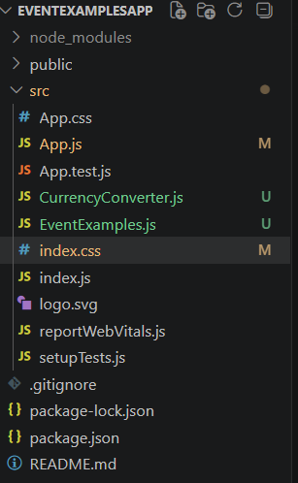

App.js
import React from "react";
import EventExamples from "./EventExamples";
import CurrencyConverter from "./CurrencyConverter";
function App(){
return(<div><EventExamples/><br/><CurrencyConverter/></div>);
}
export default App;

EventExamples.js
import React,{Component} from "react";
class EventExamples extends Component{
constructor(){super();this.state={count:0};}
increment=()=>this.setState({count:this.state.count+1});
decrement=()=>this.setState({count:this.state.count-1});
sayHello=()=>alert("Hello! Member!");
incrementAndHello=()=>{this.increment();this.sayHello();};
sayWelcome=(m)=>alert(m);
syntheticEvent=()=>alert("I was clicked");
render(){return(<div style={{margin:"20px"}}><h2>{this.state.count}</h2><button onClick={this.incrementAndHello}>Increment</button><br/><br/><button onClick={this.decrement}>Decrement</button><br/><br/><button onClick={()=>this.sayWelcome("Welcome")}>Say Welcome</button><br/><br/><button onClick={this.syntheticEvent}>Click on me</button></div>);}}
export default EventExamples;

CurrencyConverter.js
import React,{Component} from "react";
class CurrencyConverter extends Component{
constructor(){super();this.state={amount:"",currency:""};}
handleAmount=(e)=>this.setState({amount:e.target.value});
handleCurrency=(e)=>this.setState({currency:e.target.value});
handleSubmit=(e)=>{e.preventDefault();const euro=(this.state.amount/90).toFixed(2);alert(`Converting to Euro Amount is €${euro}`);};
render(){return(<div style={{margin:"20px"}}><h1 style={{color:"green"}}>Currency Convertor!!!</h1><form onSubmit={this.handleSubmit}><label>Amount</label><br/><input type="number" value={this.state.amount} onChange={this.handleAmount}/><br/><br/><label>Currency</label><br/><input type="text" value={this.state.currency} onChange={this.handleCurrency}/><br/><br/><button type="submit">Submit</button></form></div>);}}
export default CurrencyConverter;

index.js
import React from "react";
import ReactDOM from "react-dom/client";
import "./index.css";
import App from "./App";
const root=ReactDOM.createRoot(document.getElementById("root"));
root.render(<React.StrictMode><App/></React.StrictMode>);

index.css
body{
font-family:Arial;
margin:20px;
}

Output
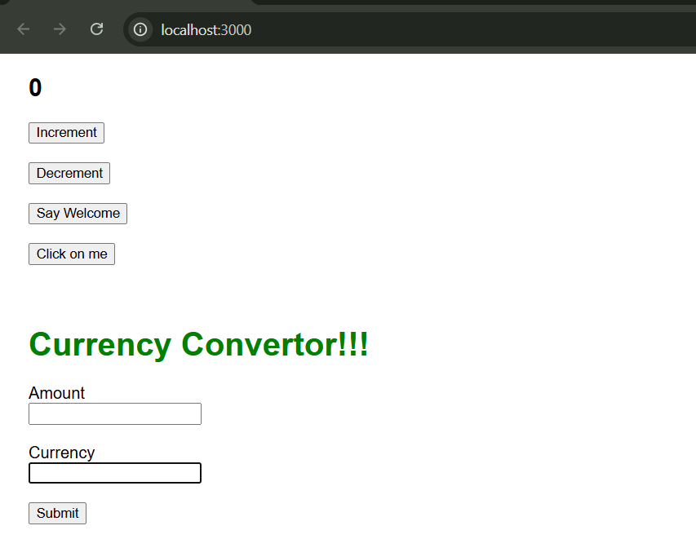

1️⃣ Increment
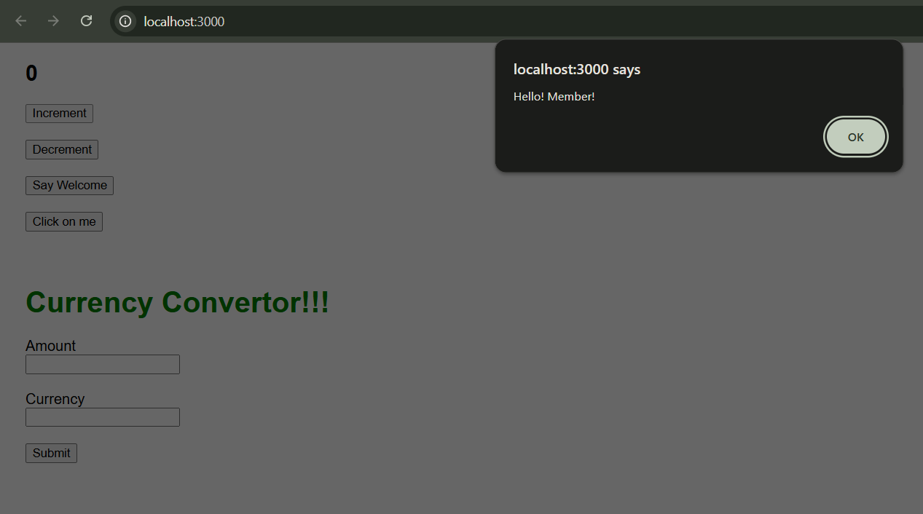

2️⃣ Say Welcome
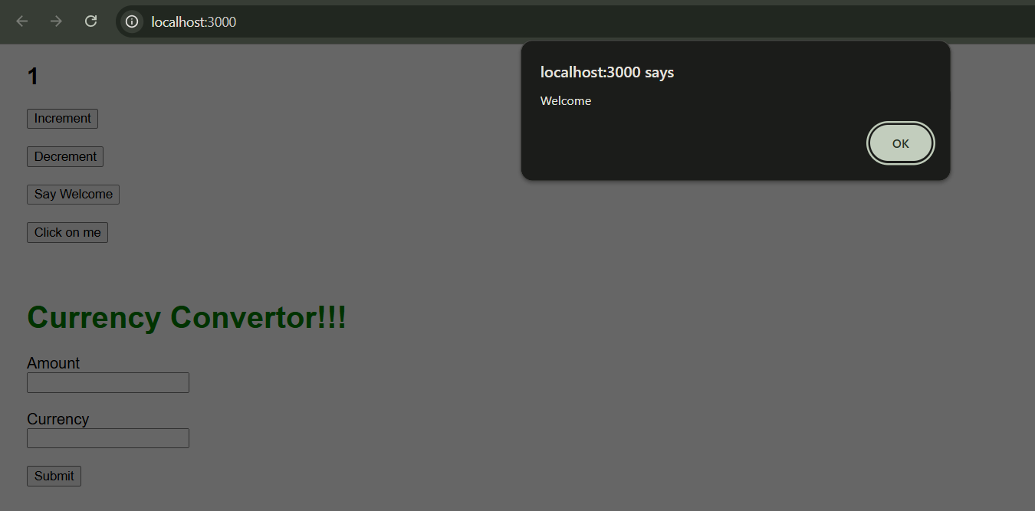

3️⃣ Click on me
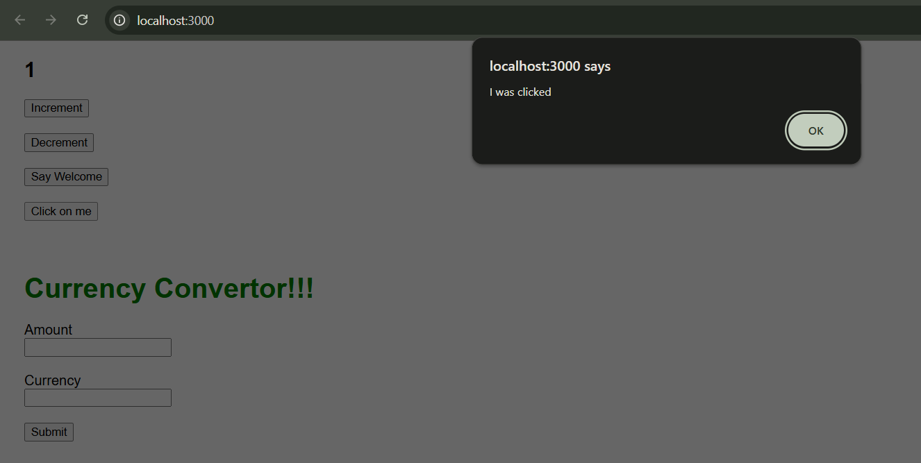

4️⃣ Currency Converter
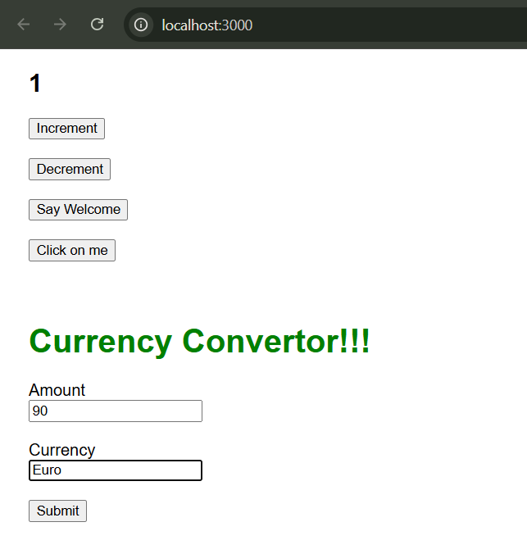
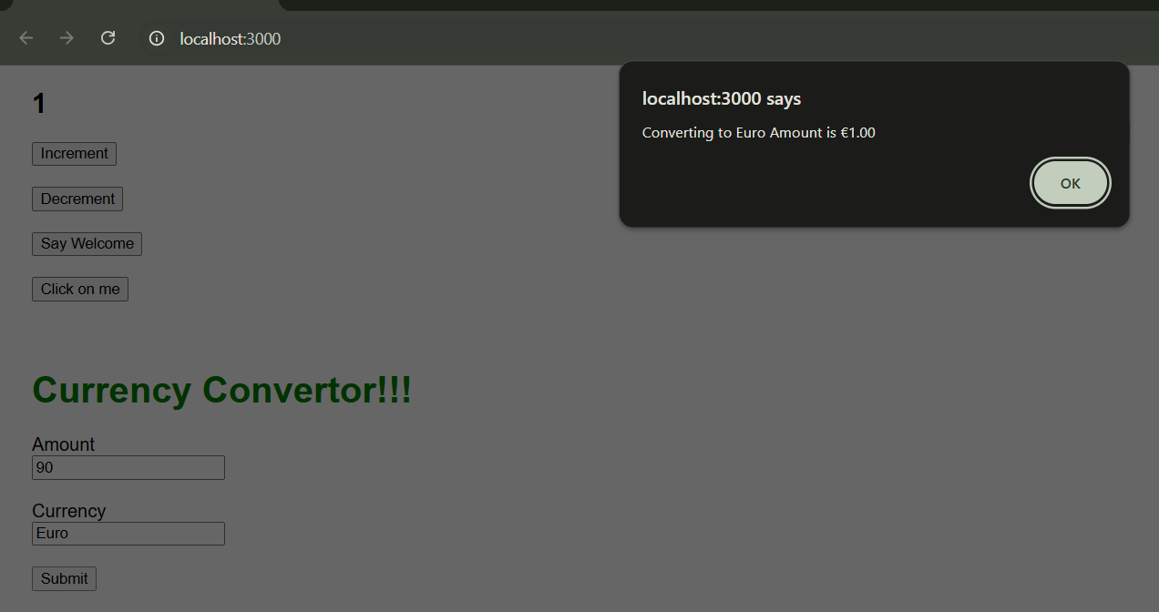

Conclusion
The application demonstrates React event handling, synthetic events, state updates, multiple method invocation and form handling.

